**1050 Programming Logic**

Lab 4 (20 points total)

Name: Dhruvil Patel

*Paste your code and screenshots below.*

1. Describe the four basic elements of the counter-controlled repetition (2 points).

Ans. The four basic elements of the counter-controlled repetition are a control variable, the initial value, the increment or decrement by which the control variable is modified each iteration of the loop and the loop-continuation condition.

1. Compare and contrast the while and for repetition statements (1 points).

Ans. A for loop is used when you know how many times a loop will execute and a while loop is used when you don’t know how many times the loop will execute.

1. Discuss a specific example when it would be more appropriate to use a do-while statement than a while statement. Explain why (2 points).

Ans. You would use a do while loop instead of a while loop when you want the body of the loop to be executed at least once regardless of the condition. This is because, in a while loop, the condition is evaluated, and the loop is only executed if found true. Whereas, in a do while loop, the body of the loop is executed at least once before evaluating the condition.

1. Create a for loop that goes from 1-100 using a variable named i as the counter. Each time through the loop, output whether or not the variable is even or odd (3 Points)

*Hint:* Use and if-else statement and the modulus % operator to determine whether the variable is even or odd. Example: if ((i % 2) == 0) // it’s even

Code:

for (int i = 1; i < 101; i++)

{

Console.WriteLine(i);

{

if ((i % 2) == 0)

{ Console.WriteLine("Number is even"); }

else if ((i % 2) != 0)

{ Console.WriteLine("Number is odd"); }

}

}

Execution:

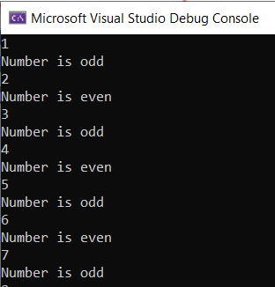

1. Use an if…else-if…else statement to output the following based on an int temp that is input by the user (3 Points) Prompt the user with “Please enter a temperature”.

**Input output**

< 10 Polar Bear

< 20 Penguin

< 40 Moose

< 50 Reindeer

< 60 Deer

< 70 Turtle

< 80 Lion

< 90 Fish

Default Bug

Code:

Console.Write("Please enter a temperature: ");

int temp = Convert.ToInt32(Console.ReadLine());

if (temp < 10) { Console.WriteLine("Polar Bear"); }

else if (temp < 20) { Console.WriteLine("Penguin"); }

else if (temp < 40) { Console.WriteLine("Moose"); }

else if (temp < 50) { Console.WriteLine("Reindeer"); }

else if (temp < 60) { Console.WriteLine("Deer"); }

else if (temp < 70) { Console.WriteLine("Turtle"); }

else if (temp < 80) { Console.WriteLine("Lion"); }

else if (temp < 90) { Console.WriteLine("Fish"); }

else { Console.WriteLine("Bug"); }

Execution:

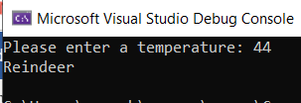

1. Use a switch statement to output the following based on an int input that corresponds to an exhibit at the zoo (3 points). Prompt the user with “Please enter the exhibit number: “

**Input output**

1 Polar Bear

2 Penguin

3 Moose

4 Reindeer

5 Deer

6 Turtle

7 Lion

8 Fish

9 Bug

Code:

Console.WriteLine("Please enter the exhibit number: ");

string str = Console.ReadLine();

int caseSwitch = int.Parse(str);

switch (caseSwitch)

{

case 1:

Console.WriteLine("polar bear ");

break;

case 2:

Console.WriteLine("penquin ");

break;

case 3:

Console.WriteLine("moose ");

break;

case 4:

Console.WriteLine("reindeer ");

break;

case 5:

Console.WriteLine("deer ");

break;

case 6:

Console.WriteLine("turtle ");

break;

case 7:

Console.Write("lion ");

break;

case 8:

Console.WriteLine("fish ");

break;

case 9:

Console.WriteLine("bug ");

break;

}

Execution:

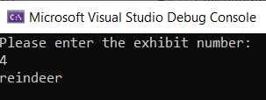

1. The following code is meant to loop and output 10-20, each number on a separate line. What’s wrong? Fix the problem. (3 points)

int i = 10;

while (i < 21)

{

Console.WriteLine(i);

}

*Example output:*



Ans. Add i++; after the console statement.

Correct Code:

int i = 10;

while (i < 21)

{

Console.WriteLine(i);

i++;

}

1. *The following statement is supposed to output every number from 0-100 separated by a line with asterisks on it. What is wrong with the code? Fix it. (3 points)*

for (int i = 0; i < 101; i++)

Console.WriteLine(i);

Console.WriteLine("********");

*Example output:*

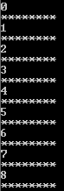

Ans. There should be curly bracket before the first console and after the second console.

Correct Code:

for (int i = 0; i < 101; i++)

{

Console.WriteLine(i);

Console.WriteLine("********");

}

1. **Extra Credit:** Write an application that displays the following patterns separately, one below the other. Use for loops to generate the patterns. All asterisks (*) should be displayed by a single statement of the form Console.Write( '*' ); which causes the asterisks to display side by side. A statement of the form Console.WriteLine(); can be used to move to the next line. A statement of the form Console.Write( ' ' ); can be used to display a space for the last two patterns. There should be no other output statements in the application. [Hint: The last two patterns require that each line begin with an appropriate number of blank spaces.] (4 Points – 1 per correct solution)

